练习1

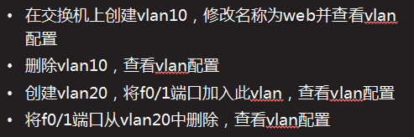

在交换机上创建vlan10，修改名称为web并查看vlan配置

Switch>enable

Switch#configure terminal

Switch(config)#vlan 10

Switch(config-vlan)#name web

Switch(config-vlan)#end

Switch#show vlan brief

删除vlan10，查看vlan配置

Switch#configure terminal

Switch(config)#no vlan 10

Switch(config)#end

Switch#show vlan brief

创建vlan20，将f0/1端口加入此vlan，查看vlan配置

Switch#configure terminal

Switch(config)#vlan 20

Switch(config-vlan)#exit

Switch(config)#interface fastethernet 0/1

Switch(config-if)#switchport access vlan 20

Switch(config)#end

Switch#show vlan brief

将f0/1端口从vlan20中删除，查看vlan配置

Switch#configure terminal

Switch(config)#interface fastethernet 0/1

Switch(config-if)#no switchport access vlan 20

Switch(config)#end

Switch#show vlan brief

练习2

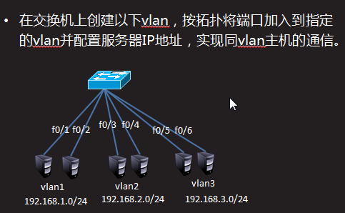

Switch>enable

Switch#configure terminal

Switch(config)#vlan 2

Switch(config-vlan)#vlan 3

Switch(config-vlan)#exit

Switch(config)#interface range fastEthernet 0/3-4

Switch(config-if-range)#switchport access vlan 2

Switch(config-vlan)#exit

Switch(config)#interface range fastEthernet 0/5-6

Switch(config-if-range)#switchport access vlan 3

Switch#show vlan brief

练习3

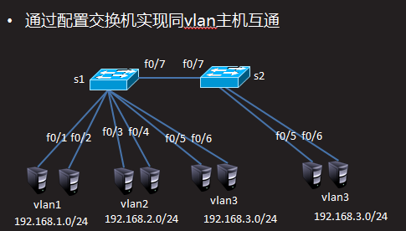

S1配置

Switch#configure terminal

Switch(config)#interface fastethernet 0/7

Switch(config-if)#switchport access vlan 3

S2配置

Switch>enable

Switch#configure terminal

Switch(config)#vlan 3

Switch(config-vlan)#exit

Switch(config)#interface range fastEthernet 0/5-7

Switch(config-if-range)#switchport access vlan 3

练习4

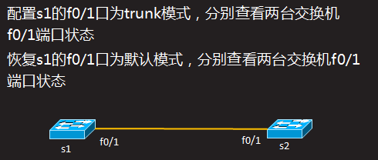

配置s1的f0/1口为trunk模式，分别查看两台交换机f0/1端口状态

Switch>enable

Switch#configure terminal

Switch(config)#interface fastEthernet 0/1

Switch(config-if)#switchport mode trunk

Switch(config-if)#end

Switch#show interfaces fastEthernet 0/1 switchport

恢复s1的f0/1口为默认模式，分别查看两台交换机f0/1端口状态

Switch#configure terminal

Switch(config)#interface fastEthernet 0/1

Switch(config-if)#no switchport mode trunk

Switch#show interfaces fastEthernet 0/1 switchport

练习5

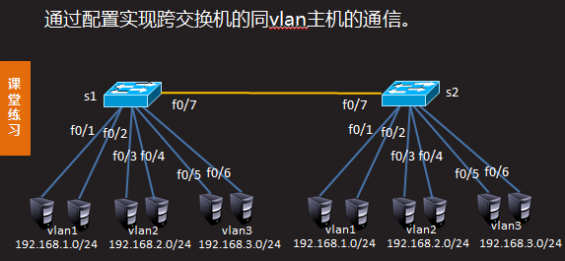

注：以下配置需要在练习3的基础上完成

S1配置

Switch>enable

Switch#configure terminal

Switch(config)#interface fastEthernet 0/7

Switch(config-if)#switchport mode trunk

S2配置

Switch>enable

Switch#configure terminal

Switch(config)#vlan 2

Switch(config-vlan)#exit

Switch(config)#interface range fastEthernet 0/3-4

Switch(config-if-range)#switchport access vlan 2

Switch(config-if-range)#exit

Switch(config)#interface fastEthernet 0/7

Switch(config-if)#switchport mode trunk

练习6

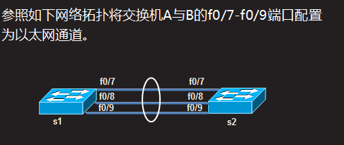

S1配置

Switch>enable

Switch#configure terminal

Switch(config)#interface range fastEthernet 0/7-9

Switch(config-if-range)#channel-group 1 mode on

Switch(config-if-range)#end

Switch#show etherchannel summary

S1配置

Switch>enable

Switch#configure terminal

Switch(config)#interface range fastEthernet 0/7-9

Switch(config-if-range)#channel-group 1 mode on

Switch(config-if-range)#end

Switch#show etherchannel summary